***Proposal on***

***“Cash & Carry”***

***Prepared for:***

**Dr. Taslim Taher Assistant Professor**

**Md. Nafis Fuad Lecturer**

**Course Number & Name:**

**CSE 3224 - Information & System Design Lab**

***Prepared by:***

**Lab Section: A1**

**Group No: 1**

**BIDYARTHI PAUL ID: 20200104023**

**DIPTA BISWAS ID: 20200104013**

**MD. ABDULLA WALID RIAZ ID: 20200104014**

**FARIHA TASNIM CHOWDHURY ID: 20200104001**

**ZAKIA SULTANA ID: 20200104005**

***Date: 23.05.2023***



***Ahsanullah University Of Science & Technology***

***Department of Computer Science and Engineering***

Project Overview

The Super Shop Management System is a software solution designed to streamline and automate the operations of a retail supermarket or hypermarket. This system aims to enhance efficiency, accuracy and customer experience by integrating various functionalities into a cohesive platform. Key features include inventory management, product catalog management, customer information management, Invoice module and user customer relationship management.

Project implementation tools/ framework

* Netbeans 8.2
* Java Swing
* JDBC Driver**:** sqljdbc 4.0
* MSsql
* SQL Server 2014 Management Studio

User Story

**As a store employee,** I want to utilize the Super Shop Management System to efficiently add new products to specific inventory categories, update product details, input customer information, update customer profiles, and generate invoices with appropriate discounts based on the customer's membership status. This will streamline the process, enhance customer satisfaction, and ensure accurate record-keeping.

**As a store employee,**

I want to enter new products into the Super Shop Management System, categorizing them according to inventory categories, So that they can be easily managed and organized for efficient stock management.

* The system should provide an interface to input new products, update, delete and assign them to relevant inventory categories, such as groceries, electronics, household items, etc.
* I should be able to specify product details including name, description, price, and quantity.

**As a store employee,**

I want to input customer information into the Super Shop Management System, So that we can provide personalized service and maintain an up-to-date customer database.

* I should be able to input customer details, including name, contact information, address, and any relevant preferences or notes, as well as update and delete them.
* The system should store the customer information securely for future transactions and loyalty program enrollment.
* Upon successful update, the changes should be reflected in the customer's profile for future interactions and transactions.

**As a store employee,**

I want to generate invoices for shopping transactions using the Super Shop Management System, Applying appropriate discounts based on the customer's membership status, So that customers receive accurate bills reflecting their membership benefits.

* The system should calculate the total price of purchased items, including any applicable vat.
* It should apply appropriate discounts based on the customer's membership status, as specified in their profile.
* The system should provide options to print the invoice.

Module breakdown

1. **User Module:**

* *User login:* Allows users to log in to the application using a username and a password by accessing the database.

1. **Product Information Management:**

* *Add Product:* Allows store employees to input products with details such as name, description, date and price to the system according to their categories.
* *Update Product:* Allows store employees to update the inventories of any products with their details.
* *Product Details:* Store employees can access the details of every product that’s been in the inventory. Updation of any product will automatically update the details shown in the product details window.
* *Delete Product:* Store employees can delete any product details according to the store requirements.

1. **Customer Information Management:**

* *Add Customer:* Enables the input of product details such as name, contact number, email, gender and availability of membership.
* *Update Customer:* Allows store employees to update the Customer details.
* *Customer Details:* Store employees can access the details of every customer who has an entry in the database. Updation of any customer will automatically update the details shown in the customer details window.
* *Delete Customer:* Store employees can delete any customer details according to the availability.

1. **Invoice generation management:**

* Store employees can search any product or customer details using only one unique key for the Invoice.
* Calculates the total price of purchased items, including applicable vats based on the customer's selection.
* Applies appropriate discounts based on the customer's membership status, as specified in their profile.
* Generates itemized invoices that include the date, time, list of products, prices and discounts.
* Provides options to print invoices for customers.

1. **Daily Sales Management:**

* Shows all the details of the products being sold with the purchased time of the customers.

1. **Log out & System Termination module**:

* *Log Out:* Allows the user to log out of the application and shows the login interface.
* *Close app:* Store employees can terminate or close the whole application.

Collaboration matrix

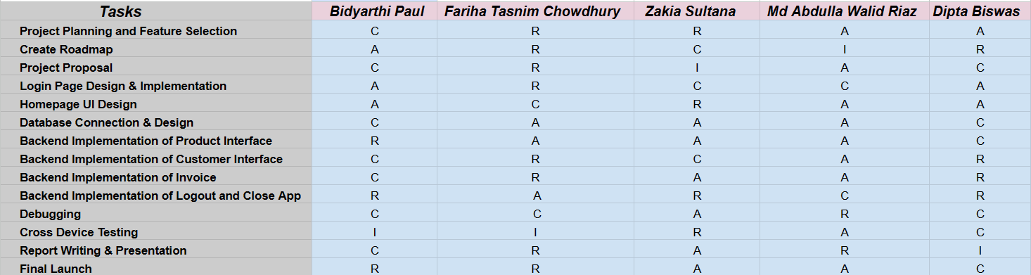

***R*** *= Responsible for the Task*

***A*** *= Accountable for the overall success or failure of the Task*

***C*** *= Consulted for the expertise*

***I*** *= Informed about the progress, decisions*

Gantt chart

*The Gantt chart presented below provides a visual representation of the project schedule and a complete roadmap for the development of our Super shop management system.*

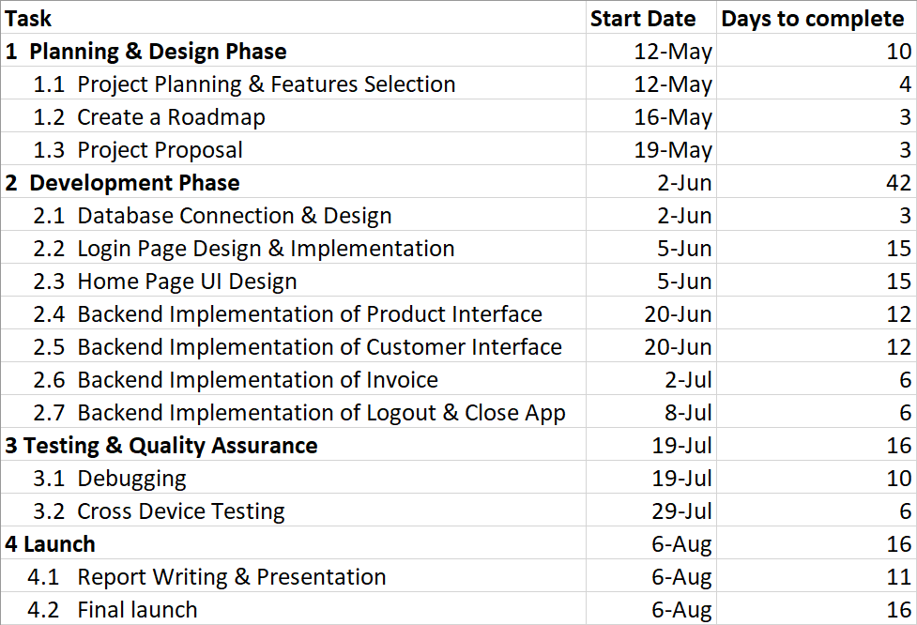

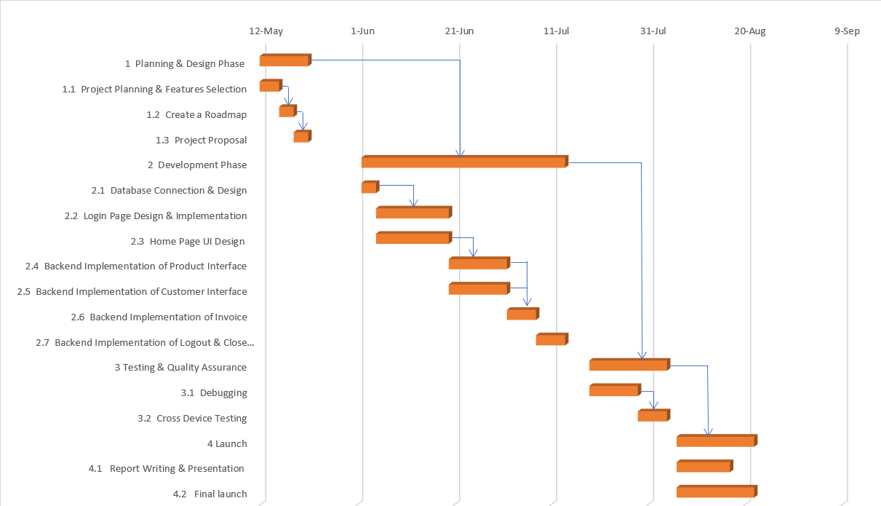

Conclusion

In conclusion, the successful implementation of our Supershop Management System will provide a comprehensive and efficient solution for retail supermarkets and hypermarkets to enhance their operations and customer experience. This project proposal sets the foundation for a well-planned and executed development process, laying the groundwork for a successful and efficient desktop application.